We are scientists! Children are emersed in their learning environments.

Aspects of science are delivered within each journey.

Science research is enabled by a range of quality key texts and use of appropriate equipment and technology.

British Science Week is embraced annually across the school and learning is then shared and celebrated in an assembly.

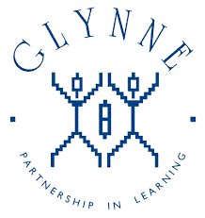

The world around us is explored within the school grounds, as well as in the classroom.

The national curriculum’s programme of study for science, is enhanced by our school curriculum to capitalise on the resources of our local area.

Linked governors are closely involved with their subject.

Visitors and characters are invited into school to bring learning to life experientially.

Year 1 and 2 visit Sandwell Valley to classify wildlife.

Science CPD is planned into staff meetings and driven by staff feedback.

Science is viewed in a cross-curricular capacity to allow and encourage our children to make strong connections about their world.

Year 5 and 6 visit Wren’s Nest to explore fossils and hunt the Dudley Bug.

Year 3 and 4 visit Dudley Zoo to look at animal adaptation and nutrition.

Teachers are supported to explore a range of ways to record and extend children’s science knowledge.

Achievement in science is recognised in assemblies.

Annual action plans are completed and reviewed by subject leads, with these being shared with governors and staff.

Subject leads work with Science Ambassadors to champion their subject.

Deep understanding of scientific vocabulary is sought and shows progresses through school.

Monitoring includes book trawls, pupil conferences, learning walks, displays and planning. Timely feedback is delivered to staff.

Records of practical science investigations are kept centrally as part of our monitoring strategy.

Science-led learning journeys in each phase.

Glynne Primary School

What does

science look like?